 | This Months Special  954-522-8772  http://www.ad-apparel.com

$15.00 Embroidered Polo Shirts

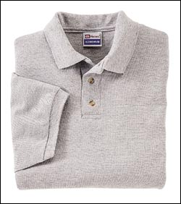 | Hanes Heavyweight 7 oz. 100% preshrunk cotton piqué. Clean-finished placket with two wood-tone buttons, welt collar and cuffs. Generous cut for a comfortable fit. Available in a complementary women’s style, giving both men and women a uniform appearance.  Sizes & Colors: All colors available in S(34-36), M(38-40), L(42-44), XL(46-48), 2XL(50-52) Size 3XL(54-56) available in white, ash, navy, red, black and forest green. Women’s style available in white, ash, navy, red, black, forest green.  

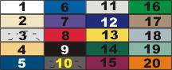 | 1 White, 2 Natural, 3 Ash, 4.Pebble, 5 Navy  6 Royal Blue, 7 Purple, 8 Red, 9 Black, 10 Charcoal Heather, 11 Light Steel, 12 Bluestone, 13 Gold  14 Forest Green, 15 Cardinal, 16 Kelly Green  17 Taupe, 18 Stonewashed Blue  19 Stonewashed Green, 20 Orange  Rely only on actual fabric color swatches for accurate color selection.

$15.00 includes left chest logo embroidery on the white Hanes shirt described above.
$50.00 digitizing charge a $75.00 value.
$1.00 extra for any shirt color other than white.
$1.00 extra for size XXL.
$2.00 extra for size XXXL.
Minimum order only 12 shirts.
OK to mix sizes in your order.
We accept all major credit cards.

